Several clubs have expressed concern that pitch conditions have meant that players are currently unable to prepare adequately for contact in league matches. This is the fourth time in five seasons that this issue has occurred, with the added challenge that pitches may be determined as unfit for play on opening weekend of September 5th for the National Leagues and the 12th /13th September for the Regional and Counties Leagues and Women’s Cup Competitions fixtures respectively. In order that we can manage and mitigate any impact on the league programme, the following protocol should be followed.

- Clubs in National League 1 & 2:
  - NLR Exec should liaise directly with National League clubs, who may by virtue of their status have made appropriate plans for both training and matches.
  - NLR is delegated to determine if matches on Week 1 can proceed and if not suggest alternative arrangements.
  - Any dispute would be dealt with in the normal manner.

- Clubs at Regional & Counties levels:
  - Where fixtures are scheduled for Week 2 (Sept 12th), clubs should advise their opposition and their league secretary of any concerns by Noon on Friday 4th September 2026, one week ahead of the fixture.
  - The League Secretary will advise clubs of the following options:
- If either club has concern over player welfare (insufficient contact training) then the match can be postponed to the Next Available Weekend (NAW).
- If both clubs are satisfied their players are ‘contact ready’ and if the home club has concerns over pitch conditions, which are unlikely to change significantly, they should approach the away club to determine if switching the fixture is possible. Such request to be discussed with league secretary by Noon on Friday 4th September.
- If there are no concerns over contact preparedness but neither pitch is fit to play, then clubs should seek alternative pitch or AGP to fulfil fixture. This is by agreement between clubs and if no agreement then match is postponed to NAW.
- At all times the league secretary MUST be advised and involved in the discussion.
- Fixtures that go down on Saturday 12th September will go over to Saturday 10th October which now reverts from a break weekend to a NAW

Please note clubs can also gain access to the RFU AGPs by contacting Rugby365@rfu.com. The map at the bottom of the document shows the locations of the RFU AGPs should anyone require it. It is fully appreciated not all clubs are local to these sites, but RFU will do their upmost to accommodate any requests.

- Women’s Game
- In relation to any Women’s Cup Competitions fixtures that will be scheduled for Week 2 (Sept 13th), clubs should advise their opposition and womenscompetitions@rfu.com at the RFU of any concerns by Noon on Friday 4th September 2026.
- Where fixtures are scheduled for Week 3 (Sept 20th), clubs should advise their opposition and womenscompetitions@rfu.com at the RFU of any concerns by Noon on Friday 11th September 2026.
- Womens Competitions will advise clubs of the following options:
- If either club has concern over player welfare (insufficient contact training) then in instance:
a) the match can be postponed to no later than the 4th October
b) a mutually agreed week in the future, teams will have a week to agree, otherwise the Next Available Weekend will be utilised.
- If both clubs are satisfied their players are ‘contact ready’ and if the home club has concerns over pitch conditions, which are unlikely to change significantly, they should approach the away club to determine if switching the fixture is possible. Such request to be discussed with Womens Competitions by Noon on
a) Friday 4th September; or
b) Friday 11th September.
- If there are no concerns over contact preparedness but neither pitch is fit to play, then clubs should seek alternative pitch or AGP to fulfil fixture. This is by agreement between clubs and if no agreement then match is postponed to NAW.
- At all times Women’s Competitions MUST be advised and involved in the discussion.

AGP Map
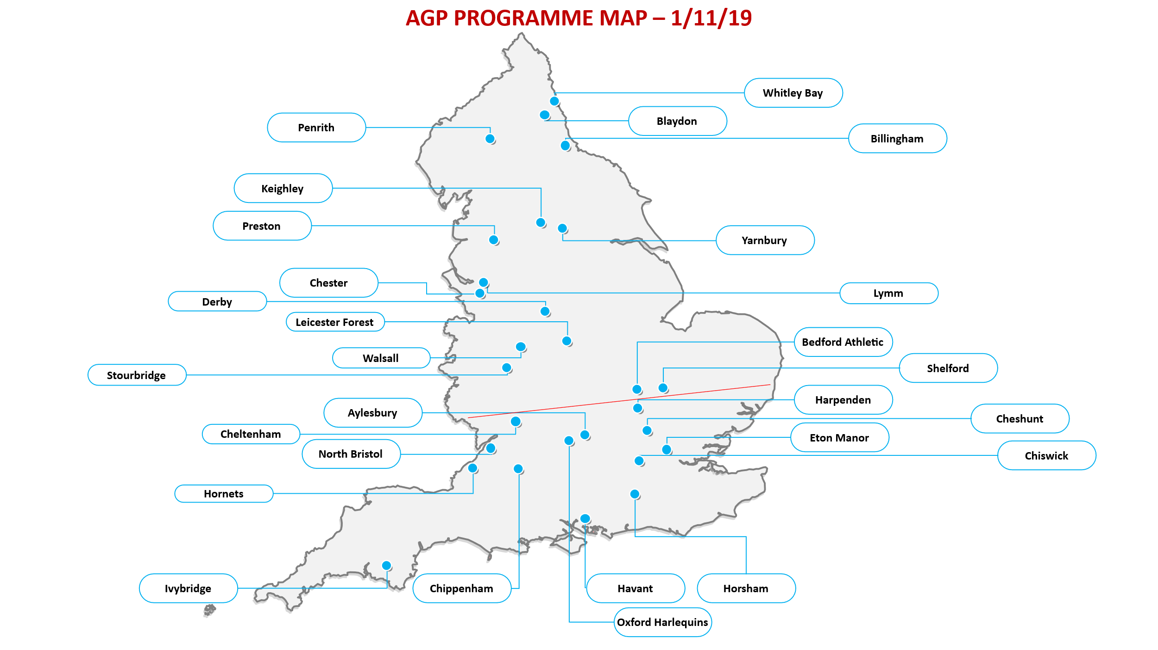

Further information & resources to support Pitch Maintenance:
- Managing rugby pitches in drought conditions.
- RFU Facilities X Account
- https://linktr.ee/RFUFacilities
- NTP Surface Risk Assessment (below)
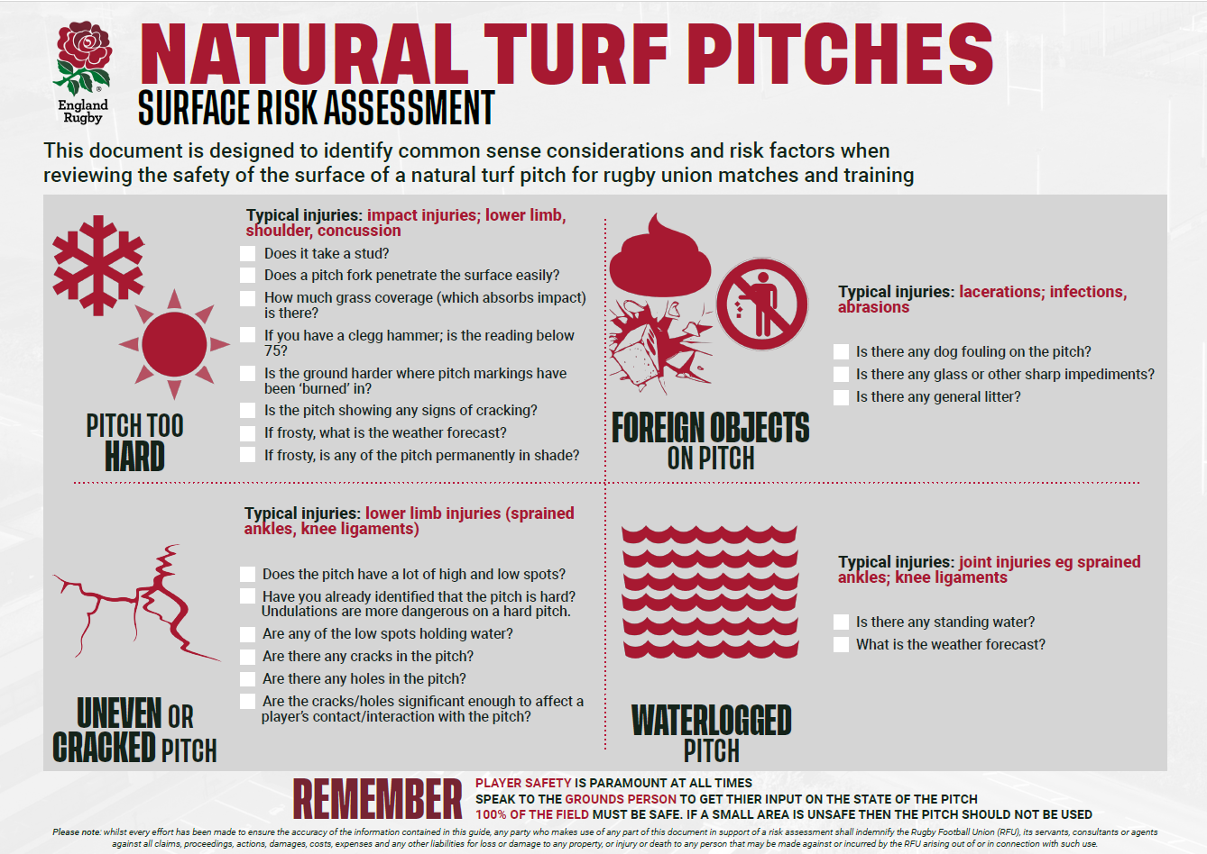

Kind Regards

Terry Burwell
Chair, Adult Competitions Management Sub Committee

Andrew Soutar
National Competitions Manager

